A Streaming Dataflow Implementation of Parallel Cocke-Younger-Kasami Parser

Dragan Bojić, Miroslav Bojović
School of Electrical Engineering University of Belgrade, Serbia
{bojic,bojovic}@etf.bg.ac.rs

Contents
1. Introduction 3
2. Problem Statement 4
2.1 Context-Free Languages 4
2.2 The CYK Algorithm 7
2.3 Modifications to the CYK Algorithm 9
2.4 Parallelizing CYK Parsing 11
3. Existing Solutions and Their Criticism 12
3.1. Existing Solutions for Shared Memory Multi-core Systems 12
3.2. Existing Solutions for Distributed Memory Systems 13
3.3. Existing Solutions for Reconfigurable Hardware Systems 14
3.4. Existing Solutions for Many-Core (GPU) Systems 16
3.5 Summary of Presented Solutions 19
4. A Dataflow Implementation of a CYK Parser 20
5. Performance Analysis 23
5.1. Modeling Space and Time Requirements 24
5.2. Experimental Analysis 25
6. Conclusion 29
Acknowledgements 29
7. References 29
Appendix 31

Abstract
Parsing is the task of analyzing grammatical structures of an input sentence and deriving its parse tree. Efficient solutions for parsing are needed in many applications such as natural language processing, bioinformatics, pattern recognition etc. The Cocke-Younger-Kasami (CYK) algorithm is a well-known parsing algorithm that operates on context-free grammars in Chomsky normal form, and has been extensively studied for execution on parallel machines. In this article we analyze the parallelizing opportunities for the CYK algorithm, and give an overview of existing implementations on different hardware architectures. We propose a novel, efficient streaming dataflow implementation of the CYK algorithm on reconfigurable hardware (Maxeler dataflow engines), which achieves 18× to 76× speedup over optimized sequential implementation for real-life grammars for natural language processing, depending on the length of the input string.

Index terms—Context-free Grammars, CYK Parallel Parsing, Dataflow Processing, Reconfigurable Architectures

Table of Abbreviations

CYK Cocke-Younger-Kasami
CKY Cocke-Kasami-Younger
CFG Context-free Grammar
CNF Chomsky Normal Form
CPU Central Processing Unit
CUDA Compute Unified Device Architecture
DFE Dataflow Engine
DMA Direct Memory Access
FPGA Field Programmable Gate Array
FPU Floating Point Unit
GNU GNU's Not Unix!
GPU Graphic Processing Unit
OpenMP Open Multi-Processing
PCFG Probabilistic context-free grammar
PCIe Peripheral Component Interface Express
SDK Software Development Kit
SLIC Simple Live CPU Interface
SM Streaming Multiprocessor
VHDL VHSIC Hardware Description Language
WSJ Wall Street Journal

1. Introduction

Languages described by context-free grammars (CFGs), are used in many applications such as natural language processing (NLP) [1], bioinformatics [2], pattern recognition [3], and several others [4,5,6]. In these applications, syntactic knowledge about the language is acquired by parsing. When huge amounts of data need to be processed, efficient low complexity parsers are required [7].

Parallel algorithms have been studied for decades, mainly in high-performance computing, but they are getting more attention in recent years due to the physical constraints preventing frequency scaling, and due to the intention to reduce power consumption (and consequently heat generation) by computers [8].

A base-line approach for exploiting parallelism in parsing is simply to parse different sentences in parallel on separate instances of the sequential parser. This is likely to be the best way to exploit parallelism with networked clusters and shared memory multi-core machines when parsing a large corpus of sentences off-line. However, there are situations where parsing speed of one sentence is subject to real time constraints, e.g., when parsing is a component of a system that interacts with users [9].

Cocke-Younger-Kasami (CYK, also known as CKY) is a well known parsing algorithm [10,11,12]. Parallel CYK parsing has been extensively studied over the last two decades. Solutions were given for various hardware architectures, both for fixed and reconfigurable hardware domains [9,13,14,15,16,17,18,19]. However we are not aware of any previous solution for explicit dataflow architecture like the one we propose in this article. Some recent implementations of various algorithms using the dataflow paradigm show considerable speed-ups, power reductions, and space savings over their implementation using the control flow paradigm [20].

The structure of the article is as follows: In section 2 we define basic notions and explain the sequential CYK algorithm, analyzing its potential for parallelization. In section 3 we give an overview of existing solutions of parallel CYK parsing on various hardware architectures, and then we summarize the most important aspects of those existing solutions, comparing them to our solution. In section 4 we explain details of our solution. The analytical performance model and experimental results are given in section 5. Section 6 is the conclusion, where we summarize our findings and give pointers for future development.

2. Problem Statement

Syntactic parsing of natural languages is the task of analyzing the grammatical structure of sentences and predicting their most likely parse trees. These parse trees can then be used in many ways to enable natural language processing applications like machine translation, question answering, and information extraction. The CYK dynamic programming algorithm [10,11,12] is used to find the parse tree or trees for a given sentence of length n in O(|G|n³) time, where |G| represents the number of rules in a grammar. While often ignored, the grammar constant |G| typically dominates the runtime in practice. This is because grammars with high accuracies have thousands of non-terminal symbols and many thousands of context-free rules, while most sentences have on average only about n=20 words. To speed up computation, the CYK algorithm can be efficiently parallelized on specialized hardware, like reconfigurable field-programmable gate array (FPGA) chip.

First, we briefly recall the definition of context-free languages and the sequential CYK algorithm. Then we discuss parallelizing this algorithm, which is the main topic of this article.

2.1 Context-Free Languages

A context-free grammar G is specified by the tuple G = (V, Σ, P, S), where V is a set of non-terminals (or variables), Σ is a set of terminals, P is a set of production rules (also called rewrite rules, or productions) and S is the start symbol, and must belong to non-terminals [21]. Non-terminals represents different types of phrases or clauses in the sentence, also called syntactic categories, e.g., VP = Verb Phrase, NP = Noun Phrase, PP = Propositional Phrase etc. Terminals are disjoint from non-terminals and they make the actual content of the sentence (e.g. kids, box, opened).

Each production rule is of the form A → γ, where A∈V (i.e. A is a non-terminal), γ∈(V ∪ Σ)*, that is, γ is a string of non-terminals and/or terminals (star denotes zero or one or more symbols).

Given a CFG G = (V, Σ, P, S) , let αAβ be a string where A∈V, and α, β and γ are strings from (V∪Σ)∗. When we use production rule A → γ, we say that A is rewritten to γ and denote this derivation step by ⇒ symbol: namely, αAβ ⇒ αγβ. When there are zero or more steps of derivation, we denote this step by ⇒∗ symbol. The language L(G) of G is then a set of terminal strings derived from the start symbol S; namely, L(G) = {w ∈ Σ∗ | S ⇒∗ w}. That is, we can derive each sentence (i.e. string of terminals) in the language L(G) by systematically rewriting each non-terminal using corresponding rules, starting from S.

For example, consider a grammar G₁: Non-terminals are S, VP, NP, TV, IV, and DatV. Terminals are saw, ate, gave, telescopes, Jack, and apples. S is the start symbol. The rules are given in Fig. 1.

1. S → NP VP  2. VP → TV NP  3. VP → IV  4. VP → DatV NP NP  5. TV → 'saw' | 6. IV → 'ate'  7. DatV → 'gave'  8. NP → 'telescopes'  9. NP → 'Jack'  10. NP → 'apples'
Figure 1 Context-free grammar G₁.

We can derive the sentence Jack saw telescopes by the application of rules 1, 9, 2, 5, and 8 respectively, in each derivation step:

S ⇒NP VP ⇒ Jack VP ⇒ Jack TV NP ⇒ Jack saw NP ⇒ Jack saw telescopes

A result of parsing can be represented in the form of a treebank or syntax tree. A treebank is a parsed text corpus that annotates syntactic or semantic sentence structure. For example, the following treebank corresponds to the previous derivation example

(S (NP Jack) (VP (TV saw) (NP telescopes)))

A syntax tree, or parse tree, is an ordered, rooted tree that represents the syntactic structure of a string according to some context-free grammar. The parse tree for our example derivation is given in Fig. 2.
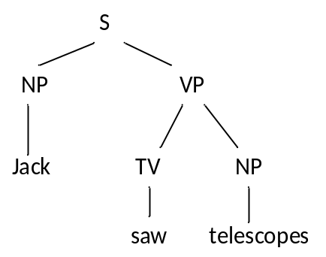
Figure 2 A parse tree for the sentence: Jack saw telescopes.

To be able to process some CFG using the CYK algorithm, the CFG needs to be in Chomsky Normal Form (CNF) [22]. We can say that a CFG G = (V, Σ, P, S) is in CNF if every production rule in P is either of the form A → BC or A → a, where A, B, C ∈ V and a ∈ Σ. It is well-known that every CFG can be transformed in to CNF. To convert a grammar to CNF, a sequence of simple transformations is applied in a certain order; this is described in most textbooks on automata theory [23].

Let us illustrate the process for our sample grammar G₁: We need only two transformations, binarization and elimination of unary productions (these transformations will be of interest to us in a later discussion).

Binarization is the elimination of right-hand sides of rules with more than 2 non-terminals.
We must replace each rule of the form

A → X₁ X₂ ... X_{n}

(with more than 2 non-terminals) X₁, ..., X_{n} by rules

A → X₁ A₁,
A₁ → X₂ A₂,
... ,
A_{n-2} → X_{n-1} X_{n},

where A_{i} are new non-terminal symbols. This does not change the grammar's produced language L(G). By applying this rule to G₁, we introduce new non-terminal NP1 and replace rule 4 with two rules, thus we obtain a new grammar G₂, shown in Fig. 3.

1. S → NP VP  2. VP → TV NP  3. VP → IV  4. VP → DatV NP1  5. NP1 → NP NP  6. TV → 'saw' | 7. IV → 'ate'  8. DatV → 'gave'  9. NP → 'telescopes'  10. NP → 'Jack'  11. NP → 'apples'
Figure 3 Context-free grammar G₂.

We will now eliminate unary rules from G₂. A unary rule is a rule of the form

A → B,

where A, B are non-terminal symbols. To remove it, for each rule

B → X₁ ... X_{n},

where X₁ ... X_{n} is a string of non-terminals and terminals, add rule

A → X₁ ... X_{n}

unless A → X₁ ... X_{n} is a unary rule which has already been removed. By applying the unary removal procedure to rule 3 of G₂, where A=VP, B=IV, we obtain the new grammar G₃, shown in Fig. 4.

1. S → NP VP  2. VP → TV NP  3. VP → 'ate'  4. VP → DatV NP1  5. NP1 → NP NP  6. TV → 'saw' | 7. IV → 'ate' (useless rule)  8. DatV → 'gave'  9. NP → 'telescopes'  10. NP → 'Jack'  11. NP → 'apples'
Figure 4 Context-free grammar G₃.

Grammar G₃ is now in CNF. Rule 7 can safely be deleted, because no other rule refers to non-terminal IV, so it is not used in derivations. From now on, we assume that an input CFG is in CNF. For more details on these topics, the reader is referred to [23].

2.2 The CYK Algorithm

Given an input string S = a₁ ... a_{n} ∈ Σ∗ and a CFG G = (V, Σ, P, S), the CYK algorithm, which is based on the bottom-up dynamic programming, determines whether S is in L(G). The standard version of CYK operates only on context-free grammars given in CNF. However any context-free grammar may be transformed to a CNF grammar expressing the same language [23].

Pseudo code for the CYK algorithm is given in Fig. 5. The main data structure that it builds is a table (or matrix) P. Each cell of P is a set of non-terminal symbols, essentially encoding information about constituent subsequences of the input sequence of words S. This algorithm considers every possible subsequence of the input sequence S and sets a non-terminal R_{A} to be a member of the matrix array P[i,j] if the subsequence of words of length i starting from j can be generated from R_{A}. Once it has considered subsequences of length 1, it goes on to subsequences of length 2, and so on.

- let the input be a string S consisting of n words: a₁ ... a_{n}.
- let the grammar contain r non-terminal symbols R₁ ... R_{r}.
- let R_{s} be the start symbol of the grammar.
- let P[n,n] be a matrix array of sets of non-terminals.
- Initialize all elements of P to an empty set.
- for each i = 1 to n
- for each terminal production R_{j} -> a_{i}
- set R_{j} as a member of P[1,i]
- for each i = 2 to n -- Length of span
- for each j = 1 to n-i+1 -- Start of span
- for each k = 1 to i-1 -- Partition of span
- for each production R_{A} -> R_{B} R_{C}
- if R_{B} is a member of P[k,j], and R_{C} a member of P[i-k,j+k]
- then set R_{A} as a member of P[i,j]
- if R_{s} is a member of P[n,1]
- then S is member of language
- else S is not member of language
Figure 5 The sequential CYK algorithm.

For subsequences of length 2 and greater, it considers every possible partition of the subsequence into two parts (controlled by variable k), and checks to see if there is some production P → Q R such that Q matches the first part and R matches the second part. If so, it records P as matching the whole subsequence. Once this process is completed, the sentence is recognized by the grammar if the subsequence containing the entire sentence is matched by the start symbol, i.e. S ∈ P[n,1].

We will illustrate CYK algorithm based on the following grammar G₄ (Fig. 6) with the start symbol S, parsing the sentence the kids opened the box on the floor.

1. S → NP VP1  2. S → NP VP2  3. PP → P NP  4. NP → Det N  5. NP → NP PP | 6. VP1 → V NP  7. VP2 → VP1 PP  8. Det → 'the'  9. N → 'kids'  10. N → 'box' | 11. N → 'floor'  12. V → 'opened'  13. V → 'box'  14. P → 'on'
Figure 6 Context-free grammar G₄.

Figure 7 illustrates the CYK matrix P for the aforementioned sentence with respect to the example grammar G₄. The loop in line 6 of the CYK algorithm is used to populate P matrix row for i=1. For example, P[1,1] ={Det} because the first word in a sequence is 'the', and there is the rule Det → 'the'. Rows of P matrix for i≥2 are filled in by the loops in lines 9-11 of the CYK algorithm. For example, in the word sequence starting from position 1 (j=1), of length 2 (i=2), the algorithm considers the sequence partitioning to the first and the second word for k=1. The sequence could be matched by the rule NP → Det N, hence P[2,1] ={NP}, because the first word is matched by the rule Det → 'the' (that is, P[1,1]={Det}), and the second word is matched by the rule N → 'kids' (that is, P[1,2]={N}). The whole triangular matrix P is populated by iterating through all remaining values of i, j and k. Finally, we conclude that the sentence belongs to L(G₄), because the start symbol could match the whole sentence, that is, S ∈ P[8,1].

i / j | 1 | 2 | 3 | 4 | 5 | 6 | 7 | 8
8 | S
7
6 |  |  | VP1,VP2
5 | S |  |  | NP
4
3 |  |  | VP1 |  |  | PP
2 | NP |  |  | NP |  |  | NP
1 | Det | N | V | Det | N, V | P | Det | N
 | the | kids | opened | the | box | on | the | Floor
Figure 7 The contents of matrix P for the CYK parse of the sentence the kids opened the box on the floor.

2.3 Modifications to the CYK Algorithm

The pair-wise approach of the CYK algorithm limits it to binary context-free grammars. Any grammar can be reduced to a binary grammar using CNF [23]. However, it is better to avoid full CNF, as the transformation looses information about unary rules of the form X → Y, where both X and Y are non-terminals. The elimination of unary rules could result in a quadratic blow-up in grammar size measured by number of rules, which consequently affects performance of some parallel CYK implementations, since it could mean more hardware resources are needed than physically available to do grammar processing in parallel.

Instead, we used a modified version of the CYK algorithm to support unary rules directly using a unary expansion process [15]. Conceptually, whenever the algorithm adds a non-terminal to a P matrix cell, we expand cell contents by adding other non-terminals that can be derived by unary rules from the original non-terminal. For example, for our sample grammar G₂, if we add IV to some P matrix cell, we should also add VP to the same cell. This process repeats on the newly added non-terminals until no more new expansions can be added.

This calculation is called closure of unary productions and can be implemented using the Warshall algorithm [24] during preprocessing of the grammar, before running the CYK algorithm. Now, the CYK algorithm is changed in line 14, such that instead of adding a unique nonterminal RA to P[i,j] set, a whole closure set of RA is added to P[i.j].

Another optimization to the sequential CYK algorithm concerns the innermost loop. Grammar productions with the same pair of non-terminals on the right-hand side, can effectively be merged together in the same memory structure. The left hand side of those productions is represented with a single set, so that all non-terminals of merged productions are members of that set (or the union of their closure sets if there are unary productions). In this way, algorithm iterates over all different non-terminal pairs on the right hand side of productions, instead of all binary productions in a grammar, which is on average 20% less for grammars used in NLP. Pseudo code for the extended CYK algorithm, which is the baseline for our parallelization approach is given in Fig. 8.

The modified CYK algorithm (Fig. 8) is for a recognizer that will only determine if a sentence is in the language. It is simple to extend it into a parser that also construct a parse tree, by storing parse tree nodes as elements of the array, instead of the Boolean value. The node is linked to the array elements that were used to produce it, so as to build the tree structure. Returning to our example of grammar G₃ and the sentence the kids opened the box on the floor, this sentence is actually ambiguous. It has two different parse trees depicted in Fig. 9, corresponding to two different meanings; hence there are multiple non-terminals recorded in matrix P from Fig. 7.

Because natural language CFGs are highly ambiguous, it is also possible to extend the CYK algorithm to parse strings using weighted and stochastic context-free grammars [25]. Weights (probabilities) are then stored in P matrix instead of Booleans, so P[i,j] will contain the minimum weight (maximum probability) that the substring from i to j can be derived from A (for every grammar non-terminal). Further extensions of the algorithm allow all parses of a string to be enumerated from lowest to highest weight (highest to lowest probability). These last two extensions of the algorithm (reconstructing the parse tree and handling stochastic grammars) are outside the scope of our research that deals only with recognizing a sentence membership to the language defined by a CFG.

- let the input be a string S consisting of n words: a₁ ... a_{n}.
- let the grammar contain r non-terminal symbols R₁ ... R_{r}.
- let R_{s} be the start symbol of the grammar.
- let P[n,n] be an array of sets of non-terminals.
- let closure[n] be a vector of sets of non-terminals.
- let map[R_{x},R_{y}] be a map collection of sets of non-terminals.
- Initialize all elements of P and map and closure to an empty set.
- -- calculation of closure sets
- for each i = 1 to r
- set R_{i} as a member of closure[R_{i}]
- for each unary production R_{j} -> R_{i}
- set R_{j} as a member of closure[R_{i}]
- -- apply the Warshall algorithm
- for each i = 1 to r
- for each j = 1 to r
- for each k = 1 to r
- if R_{j} is a member of closure[R_{i}]
- and R_{k} is a member of closure[R_{j}]
- then set R_{k} as a member of closure[R_{i}]
- -- calculation of map sets
- for each production R_{A} -> R_{B} R_{C}
- add all elements of closure[R_{A}] to map[R_{B},R_{C}]

- -- end of preprocessing, start of parsing
- for each i = 1 to n
- for each terminal production R_{j} -> a_{i}
- add all elements from closure[R_{j}] to P[1,i]
- for each i = 2 to n -- Length of span
- for each j = 1 to n-i+1 -- Start of span
- for each k = 1 to i-1 -- Partition of span
- for each element (R_{B},R_{C}) => X from the map collection
- if R_{B} is a member of P[k,j], and R_{C} a member of P[i-k,j+k]
- then add all elements from X to P[i,j]
- if R_{s} is a member of P[n,1]
- then S is member of language
- else S is not member of language
Figure 8 A modified CYK algorithm that we used as a basis for our parallelization research.

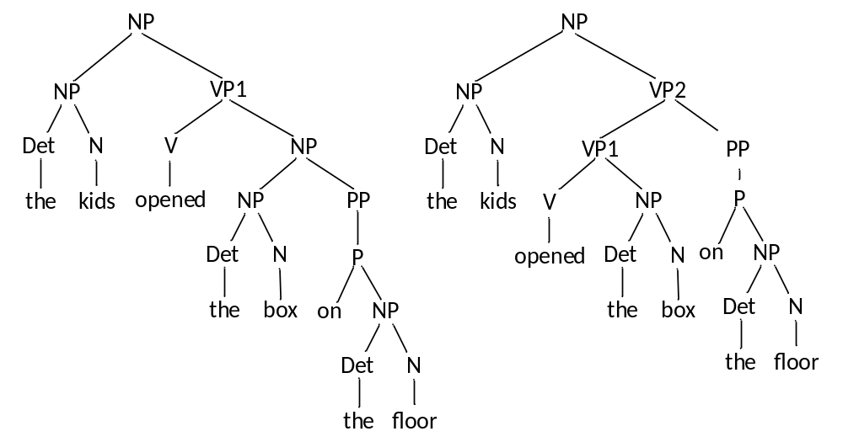
Figure 9 Different parse trees for the sentence: the kids opened the box on the floor.

2.4 Parallelizing CYK Parsing

When parallelizing any algorithm, it is important to consider the algorithm’s work and span [26]. Work is the total amount of computation performed by the algorithm, across all processors (or, equivalently, the total time taken when run on one processor). The span is a theoretical measure of the fastest time an algorithm could execute given an infinite number of processors. An algorithm’s span is limited by its critical path, the longest sequence of computations that depend on each other’s results. The ratio of an algorithm’s work to its span limits its speed-up, or the performance it can achieve relative to its single processor performance. An ideal parallel algorithm achieves linear speed-up; that is, given P processors, it will execute P times faster than it would on one processor.

CYK is an instance of dynamic programming algorithms; this means that it divides the parsing problem into smaller sub-problems that can be solved separately. This structure makes them amenable to parallelization because the separate sub-problems can often execute in parallel. CYK parallelizes very well because the dependencies between operations are very sparse and well-defined. Because so many of the computations involved in CYK parsing are independent of each other, CYK algorithm gives many opportunities for parallel computation.

The traversal order of the CYK chart itself is under-constrained, a fact we exploit when introducing parallelism later. For example, we can exchange the order of two inner loops (with indices j and k), to make data access more regular (sequential), which results in better cache utilization in shared memory configuration. In fact, we can traverse the CYK chart in any order, as long as each cell is visited after all cells to its left and all cells below it have been visited.

The innermost loop, one that iterates over grammar productions, is do-all kind of loop. We can process each production independent of others. This fact is used in several hardware solutions (on reconfigurable FPGA chip) to parallelize and thus speed up processing related to the innermost loop. Elements of P matrix, which are often implemented as bit arrays of several memory words (for large number of non-terminals) could also be processed in a do-all fashion, for union operations.

Important properties of a solution, beside the speed-up, are its scalability and extensibility [16]. Scalability refers to tailoring the solution to the characteristics of any given CNF grammar so that no hardware resources are wasted. Extensibility is achieved if the solution does not restrict maximum grammar size, but the size can be increased on demand by using more hardware units.

The exact way a parallel algorithm is constructed from sequential one, depends of underlying hardware architecture. In the next section, we will give an overview of existing solutions for several different hardware architectures. Then we will discuss our innovative way of parallelizing CYK parsing for streaming dataflow architecture.

3. Existing Solutions and Their Criticism

First we give an overview of related techniques classified according to the target architecture, and then we summarize the most important aspects of those existing solutions, comparing them to our solution.

3.1. Existing Solutions for Shared Memory Multi-core Systems

Manousopoulou et al. [27] in 1997 implemented the parallel CYK parser on a multi-core system, where the limited parallelization possibilities provided by the systems restrict the speed-ups that can be achieved (7-8×). A similar approach from van Lohuizen [28] in 1999 reports a mere 1.8× speed-up. The best speed-up in this category of algorithms of 15.2× for 16 core processor (nearly linear) is reported by Boyd-Wickizer et al. [15] in 2009.

Boyd-Wickizer et al. [15] employed several techniques to achieve this level of parallelism: at the P matrix cell level of parallelism (the outer two loops with indices i and j, lines 9 and 10 in Fig. 5), they identified data dependencies between cells, and made a transitive reduction of dependency graph (removed transitive arcs, as in Fig. 10).

The solution [15], each cell value is computed using one thread, with a push model of thread synchronization, where cells do not wait on other cells to complete. Instead, when a cell calculation completes, its thread checks if it is the last dependency of any other cells and, if so, spawns the computations of those cells. This model scales well to large number of short lived threads. The technique [15] also uses cache aware partitioning by dividing the CYK inner loops processing into chunks that fit into cache. Other techniques include tracking dependencies on the level of individual rule processing inside each cell.
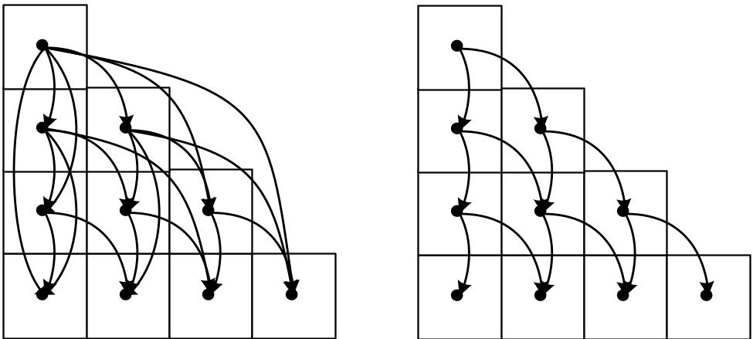
Figure 10 Full and reduced P matrix cell dependencies.

3.2. Existing Solutions for Distributed Memory Systems

Takashi et al. [19] in 1997 proposed a parallel CKY parser on a distributed memory machine, Fujitsu AP1000+ consisting of 256 nodes, where each node contains a single processor (Super Sparc 50 MHz with 16 MB of memory). AP1000+ architecture is presented in Fig. 11. It has three networks; a broadcast network (B-net; 25MB/s), a torus network (T-net; 50 MB/s per a link), and a synchronization network (S-net). On the AP1000+ a processing unit is called a cell. Each cell is controlled by a host machine using the B-net and S-net. The AP1000+ offers special instructions which allow remote memory accesses. The remote memory access does not disturb a remote processor (which implements a write through cache policy). Each cell can read remote memory with a get instruction and write with a put instruction.

The operating system of this machine is called Cell-OS, which offers a single-user and a single-program operating environment. Under Cell-OS, the machine is reset before launching each parallel program, and the kernel is loaded with the parallel program.

Using a specific parallel language ABCL/f, Takashi et al. [19] parallelized CYK over elements of P matrix. More specifically, although the order of traversing P matrix is somewhat different than in the baseline CYK algorithm from Fig. 5, we can express the algorithm [19] as follows:

First, the outermost loop with index i (line 9 in Fig. 5) has been parallelized, which is the coarsest parallelism in the CYK algorithm. At this level, ideal speedup reaches n for a sentence of length n at the beginning of the parsing and decreases as parsing proceeds.

Next, the loop with index j (line 10 in Fig. 5) has been parallelized, which is the second coarsest parallelism. That is, computation of P[i,j] is a unit of parallel processing.

Next, the inner loops (lines 11 and 12 in Fig.5) have not been parallelized, but for that loops, computation of the final value of P[i,j] is done after computations of both P[i-k,j+k] and P[k,j] have been completed.

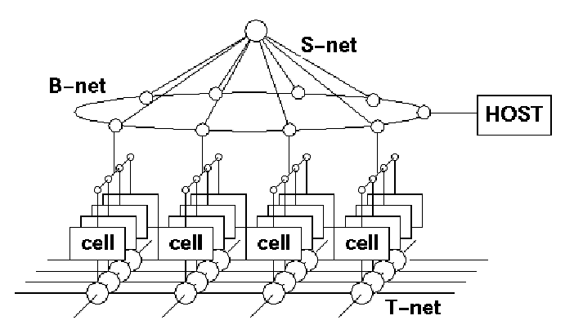
Figure 11 Fujitsu AP1000+ Distributed memory parallel machine architecture.

With a grammar of 18,891 rules and 206 non-terminal symbols, a speedup of 45× was achieved compared to an optimized C++ sequential version running on Sun Sparc Station 10 workstation, but for very long input sequences (120 words). For shorter input sequences of about 40 words, that is average length of the real corpus in Japanese of 2173 sentences used, the speedup was less than 5×. Since the parallel machine has a distributed memory system, where the synchronization among the nodes is implemented with message passing, the synchronization overhead is significant, preventing parallelization of the inner loops of the CYK algorithm.

3.3. Existing Solutions for Reconfigurable Hardware Systems

Ciressan et al. [16] in 2000 proposed and implemented an FPGA design that could be considered as a straightforward implementation of the CYK algorithm in hardware (Fig. 12). The general idea of their hardware design is to use n processors to parse a sentence containing at most n words. Each processor is responsible for calculating a column of P matrix. The CYK memory stores the sets P[i,j] and is shared for read and write by all working processors in the system (token passing priority arbiter is used). It is the task of the global controller G-CTRL to activate or deactivate the processors, and to synchronize the processors at the end of outer loop iteration. The grammar memories store identical copies of the binary representation of the CNF grammar.

During parsing, the processors intensively access the grammar memories but due to physical constraints (i.e. the number of I/O pins of an FPGA) it was not possible to have a separate grammar memory bus for each processor in the system. Instead, processors are grouped in clusters that share the same grammar memory (again, priority arbiter is used). They report a speedup of 69.9× for a real life grammar with 10,129 non-terminals and 74,350 rules in its CNF form. This is the result of a simulation of the system with 14 processors and 7 clusters (in reality they could put just 10 processors and 3 memory clusters onto their FPGA chip). The simulation limited the maximum sentence length to 14, corresponding to the number of processors in the design. The real word corpuses have larger average sentence length, about 25. The design seems to be congested around P memory, because all processors simultaneously access it.

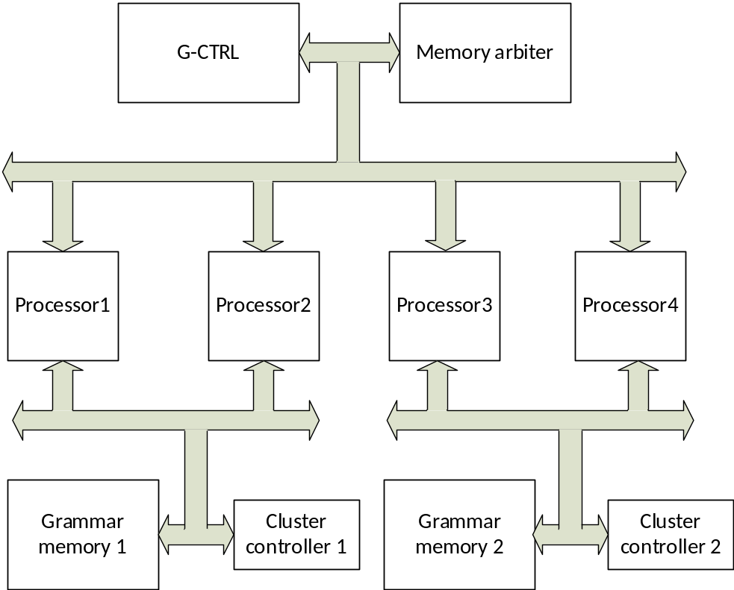
Figure 12 FPGA design with a processor per input word.

Bordim et al. [13] in 2002 studied the CYK algorithm on field programmable gate arrays (FPGAs) and developed a hardware generator that creates a Verilog HDL source performing CYK parsing for a given CFG. Their approach considers 2,048 production rules and 64 variables in an input CFG and shows a speed-up factor of almost 750×. The main idea of their approach is to accelerate the inner loop processing of CYK parser by not iterating through rules one by one. Instead, they conceptualized a huge look-up table, where the input address would consist of values of both cells P[i-k,j+k] and P[k,j]. The output from this table would be a final result to P[i,j]. It needs to be pre-computed (once per grammar, before parsing starts) considering all grammar rules for every pair of different values of P[i-k,j+k] and P[k,j]. As those values are bit arrays of r bits, a memory capacity of 2^{2r} bits is needed (2¹²⁸ in case that there are 64 non-terminals in the grammar), which is impractically large. As a result, they devised a method to look up pairs of chunks of bit arrays P[i-k,j+k] and P[k,j], which reduced the table capacity to 256Mb for 64 non-terminals, at the expense of 64 table lookups instead of just one.
Even with this optimization, the proposed approach suffers from insufficient memory or logic elements, and limits the number of rules in the grammar, and the number of non-terminal symbols. Hence it cannot be applied to real-world, state-of-the-art grammars.

Nevertheless, the idea of trading memory for processing speed via look-up tables motivated us to devise an alternative scheme, where the set of N rules is processed simultaneously by means of look-up table.

The rule processing loop of the CYK algorithm (Fig.5) consists of two set membership tests, and an update to P[i,j] matrix element:
- for each production R_{A} -> R_{B} R_{C}
- if R_{B} is a member of P[k,j], and R_{C} a member of P[i-k,j+k]
- then set R_{A} as a member of P[i,j]
The membership tests use the pre-computed part of P matrix, and are a doall kind of computation that can be done fully in parallel for all grammar rules (subject to the amount of available hardware on an FPGA chip). P[i,j] set update, on the other hand, is an aggregate function. Theoretically, it could be realized using combinatorial logic elements with a large fan-in. In practice, multiple pipeline stages are required for FPGA synthesis to succeed, effectively decreasing the performance to one rule per clock cycle. To speed up P[i,j] calculations, and avoid large fan-in logic, we used a special look-up table. The membership test yields one bit result per each rule. The set of those N bits is used as an address to a look-up table, which returns a pre-computed result which is a union of left hand sides of all rules from the set that has 1 in a look up address. This approach could be applied regardless of the total number of rules in the grammar, hence it has excellent scalability. If we use multiple (say M) look-up tables, than we can process M*N rules in parallel. The optimal values of M and N have to be empirically determined. The details of our approach are given in section 4.

3.4. Existing Solutions for Many-Core (GPU) Systems

Johnson [9] in 2011 examined the CYK algorithm for dense probabilistic context-free grammars (PCFGs) and constructed a dense PCFG with 32 variables and 32,768 production rules with random probability. The author reported an 18.4× speed-up obtained on NVIDIA Fermi s2050 GPUs, and suggested a reduction method in one block for calculating the probability.

Dunlop et al. [29] in 2011 presented a matrix encoding of CFGs using a multiplication method for a matrix low-latency parallelized CYK algorithm, with up to 9× speed-up for probabilistic CFGs. They encoded the grammars of CFG in a matrix form in which the rows are the left-hand side variable of the production and the columns are the right-hand side variables (pairs in CNF).

Yi et al. [25] in 2014 proposed an efficient parallel CYK algorithm for natural language parsing of PCFG on GPUs. A PCFG is a CFG in which each production is augmented with the probability. Their algorithm assigns each production rule of an input PCFG to each core in a GPU and finds the valid parsing rules quickly. They claim a 26× speed-up compared to a sequential C implementation.

We will examine a recent (2014) solution for parallel CYK implementation in CUDA programming model Kim et al. [18], because they parallelized the algorithm that is of interest to us.

CUDA allows programmers to utilize NVIDIA GPUs to accelerate applications in domains other than graphics. A CUDA program calls parallel kernels. A kernel executes in parallel across a set of parallel threads. The programmer or compiler organizes these threads in thread blocks and thread blocks grids. The GPU instantiates a kernel program on a grid of parallel thread blocks [30].

Each thread within a thread block executes an instance of the kernel, and has a thread ID within its thread block, program counter, registers, per-thread private memory, inputs, and output results. A thread block is a set of concurrently executing threads that can cooperate among themselves through barrier synchronization and shared memory.

In the CUDA parallel programming model (shown in Fig. 13), each thread has a per-thread private memory space used for register spills, function calls, and C automatic array variables. Each thread block has a per-block shared memory space used for inter-thread communication, and for sharing of parallel algorithms data and results. This shared memory has two orders of magnitude less latency than the off-chip global memory, but is very small (16KB to 64KB, depending on the architecture). CUDA therefore provides the programmer with the flexibility (and burden) to explicitly manage shared memory (i.e., loading a value from global memory and storing it).

Grids of thread blocks share results in Global Memory space after kernel-wide global synchronization [30]. There is also a so called texture memory for storing constant values, read only memory for GPU, writable only by the CPU.

The CUDA’s hierarchy of threads maps to a hierarchy of processors on the GPU. The GPU executes one or more kernel grids; a streaming multiprocessor (SM) executes one or more thread blocks; and CUDA cores and other execution units in the SM execute threads. To improve performance by memory locality, the SM executes threads in groups called warps [30]. In typical GPUs, a warp consists of 32 threads that share the units for instruction fetching and execution. Thus, a thread cannot advance to the next instruction if other threads in the same warp have not yet completed their own execution. On the other hand, threads in different warps are truly independent: they can be scheduled and executed in any order. Up to two warps are scheduled to execute on each SM.

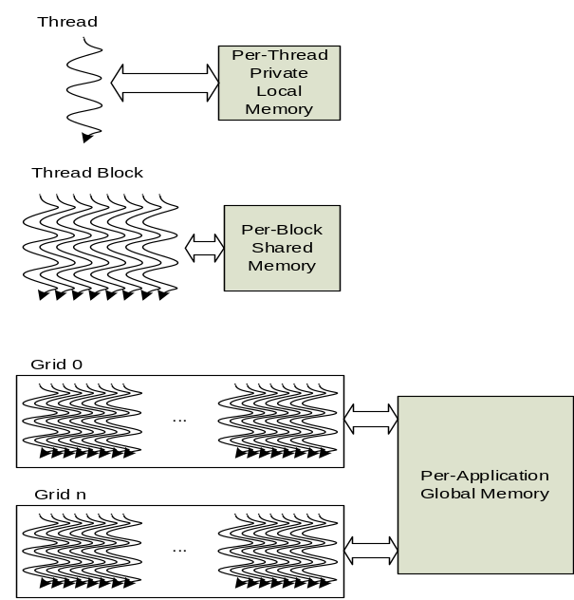
Figure 13 The CUDA programming and memory models.

One of the important factors for designing parallel algorithms is how to map the input data to the threads for fast parallel processing. Kim et al. [18] start from a variant of the CYK algorithm where the loop with index k, and the loop over rules are interchanged. They map the second loop (with index j) to thread blocks, and the loop over rules to threads. They consider three different methods of mapping grammar rules to threads: rule based (mapping rules in the order they appear in the grammar), left-variable sorting, where rules are grouped by their left-hand sides before mapping to threads (thereby reducing shared memory requirements for intermediate results), and right-variable sorting, where rules are sorted by the first non-terminal on the right-hand side before mapping to threads (thereby increasing thread performance by reducing thread divergence). They also add dummy rules to reduce thread divergence (avoid boundary conditions) and thus improve thread execution performance at the cost of additional memory accesses.

They experimented with different methods of mapping CYK data structures to CUDA memory hierarchy. They tried storing rule data in global memory, in texture memory, and with storing intermediate results (a value of P matrix cell for a particular non-terminal) in shared memory – the final P matrix is in global memory.

They experimented with a grammar obtained from a Penn Treebank with 98 non-terminals and 3840 binary rules, using NVidia 560 Ti GPU with 8 streaming multiprocessors having in total 384 CUDA cores, with 1GB of global memory, and 48KB of shared memory size. The CPU was Core i3 3.10GHz with 8 GB of operating memory. The greatest speedup is 8.41× over sequential CYK version for a combination of using left variable sorting, shared memory and dummy rules, but for a relatively small grammar. With a full size grammar, they obtain 8.21× speedup using the right-variable sorting, and without using the shared memory. They notice that using texture memory over global memory for storing grammar rules does not increase performance of the algorithm.

3.5 Summary of Presented Solutions

Following the overview of existing solutions to parallelize CYK parser algorithm, Table 1 gives a summary comparison of selected solutions in terms of most important parameters with our solution. We have chosen the best performing solution in terms of speedup to sequential CYK version from each architecture category described in sections 3.1-3.4. We are mostly interested in solutions that solve the exactly same problem as ours, namely CYK recognizer. However, we also included a few solutions that are dealing with the probabilistic CYK algorithm, because this algorithm is structurally similar to basic algorithm, the main difference being that it needs floating point arithmetic operations instead of logical operations (on bit arrays representing sets of non-terminals). Because of that structural similarity, the basic ideas for parallelization could be reused for both types of algorithms (but a hardware needs are different).

In Table 1 for each solution, we list best achieved speed-ups (it is usually not a single value, but a range of values depending of parameters such as grammar size and the length of input), the hardware architecture it is targeted to, the variant of CFG it could directly process, the size of grammar, and the length of input sequences used in experimentation, whether the verification was performed by actually running the parallelized solution or just simulating it, and about the scalability and extensibility properties as we defined them in section 2.4.

Table 1 A Summary of existing solutions to parallel CYK parsing
Authors and year | Speedup  range | Parallel Architecture | CFG type | CFG vars/rules/ input length | Verification | Scalable  /Extensible
Boyd-Wickizer (2009) [15] | 15.2× | Multi-core (16) CPU | CNF/w unary rules | 2800/13400/  7-16 | experimental | Yes/yes
Takashi  (1997) [19] | 5×  –  45× | Distributed memory symmetric  (256 nodes) | CNF | 200/19000/  40-120 | experimental | Yes/yes
Ciressan et al. (2000)[16] | 10× –  69.9× | FPGA/  VHDL | CNF | 10100/74000/  3-15 | Simulation | Yes/  potentially
Bordim et al. (2003) [13] | 750× | FPGA/  Verilog | CNF | 64/2048/  32 | experimental | No/?
Yi et al.  (2014) [25] | 25.8× | GPU  (480 cores) | PCFG /CNF | 1120/900000/  ~20 | experimental | Yes/?
Kim et al.  (2014) [18] | 8.41× | GPU  (384 cores) | CNF | 98/3840/  ~20 | experimental | Yes/?

Because the solutions are from different years, implemented on different technology generations, there is no sense of comparing actual runtimes of solutions, but just their speed-up values. The speedup is defined as the ratio between parsing runtime on sequential hardware and a parallel one belonging to the same technology generation. The cautionary note is that those values from different solutions are not directly comparable, but should be put in perspective with parameters of grammars and the length of input sequence. The solutions that are measured using real grammars (number of non-terminals at least 1000, number of rules at least several thousand) and that are verified by running an actual implementation in parallel are much more credible than solutions using toy examples, too long input sequences or just simulating the algorithm behavior. Also, there is no standard (benchmark) implementation of the sequential CYK algorithm, and it also greatly affects the overall speed up value. We have chosen to present speed-up values in comparison to “canonical” CYK implementations as it is described in the literature when introducing it, with the usual set of compiler optimizations and with a choice efficient data structures for representing P matrix), and not some special restructured variants that are using the ideas obtained from parallel implementations (e.g. by introducing huge look-up tables to trade space for run time, etc).

4. A Dataflow Implementation of a CYK Parser

Our solution of parallel CYK parsing is targeted to streaming dataflow architecture of reconfigurable hardware accelerators offered by Maxeler Technologies, a fast expanding high-performance computing company with roots at Stanford, Bell Labs, in the United States, and Imperial College, London, in the United Kingdom.

Figure 14 sketches the architecture of a Maxeler hardware acceleration system which equips one or more Dataflow Engines attached to a set of memories and connected to a host CPU via PCI Express channels [31]. Accelerating an application involves analyzing the entire application, adapting program structure and partitioning the execution flow and data layout between CPUs and accelerators. The program of the Dataflow Engines comprises arithmetic data-paths for the computations (the kernels) and modules orchestrating the data I/O for these kernels (the manager).

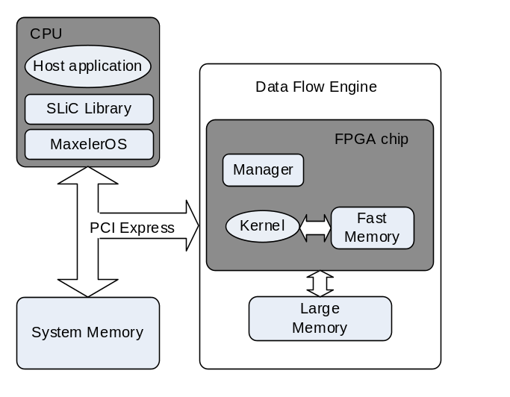
Figure 14 The Maxeler accelerator architecture.
The Maxeler Kernel Compiler generates configuration of hardware, which configured forms the Dataflow Engines used as accelerators to the CPU. Therefore, the program describes computations structurally (computing in space) rather than specifying a sequence of processor instructions (computing in time). The main unit of processing is a kernel, which is a streaming core with a data flow described by a unidirectional graph. Subsequently, data streams through the arithmetic nodes. Efficient streaming kernels strongly emphasize the regularity of the data flow, making the actual computations look like a side-effect of streaming. These kernels are suitable for deeply pipelined data flow implementation, which is crucial for achieving good performance.

We could say that our innovation belongs to classes S (specialization) and I (implantation) of the classification given in [32]. The solution specializes the parallel CYK algorithm to yet unexplored hardware architecture. The solution bears some similarities to the technique of Bordim et al. [13], in the sense that we used lookup tables to speed up grammar processing (i.e. trading space for speed), but instead of mapping pair of P matrix cells to a table result, we mapped the conditional results of matching R rules at the same time to P matrix cell. In that way we eliminated the limits of the existing solution, because our technique could be applied to grammars of any size (adjusting the level of parallelism to available hardware resources), and, at the same time, retained a solid runtime performance.

The complete kernel we developed for a CYK parser is given in the Appendix, written in MaxJ language, which is a variant of Java language used to describe the structure of the kernel. MaxJ could be regarded as a hardware description language, like VHDL or Verilog. However, MaxJ has a higher level of abstraction than those languages, which makes programmer more productive. When programming in MaxJ, a programmer thinks of dataflow graphs, stream variables, arrays, etc, and not on hardware entities like registers, signal buses, etc. The MaxJ compiler is effectively a Java software library and as such, kernel graphs are created by writing a Java program and executing it. A kernel graph behavior could be simulated (for a purpose of program testing) and eventually kernel graphs are directly mapped to hardware, using FPGA hardware synthesis tools.

Figure 15 depicts the abstracted kernel dataflow graph for the parallel CYK algorithm. Various implementation details have been left out, which produce many more nodes in the actual kernel graph.

The CYK algorithm main data structure, matrix P, is represented in the kernel by chip-internal block memory PMEM (lines 53-56 of the kernel listing in the Appendix). Its capacity is quadratic to the size of the input, and it has three read ports and one write port per clock cycle (internally MaxJ compiler generates duplicate copies of memory blocks to achieve this). PMEM is a linearized representation of P (a vector that corresponds to a row-by-row representation of matrix).

Three address generators that correspond to expressions P[k,j], P[i-k,j+k], and P[i,j] from sequential algorithm in Fig. 8, are linear combinations of the values of counters i, k, and j. Those three hardware counters are chained together as well as to counter g (g is fastest incrementing per each tick, that is clock cycle of FPGA chip), see lines 41-48 of the kernel listing in the Appendix. When counter g wraps up, then counter j increments by one, etc. Counters i, k, and j correspond to for loops in lines 28-30 of the sequential algorithm in Fig. 8 (with a change in order of k and j loops as discussed earlier). Counter g roughly corresponds to for loop in line 31 of Fig. 8 (taking into account the earlier discussion that an improved sequential algorithm iterates over set of different non-terminal pairs on the right hand sides of productions). However, in each g increment, a total of (g_parallel x g_lut) productions get processed, where g_parallel and g_lut are kernel compile time constants.

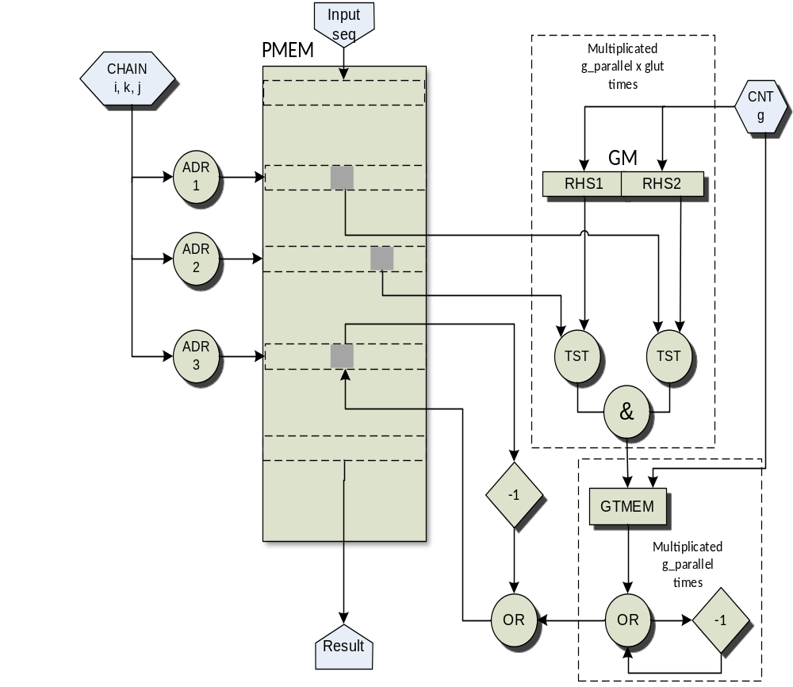
Figure 15 The abstracted kernel dataflow graph for the parallel CYK parser.

There is exactly the same number (g_parallel x g_lut) of instances of GM memory (kernel listing lines 68-71); every cell of each GM instance is composed of RHS1 and RHS2 parts, that are indices of non-terminal pairs for grammar rules. Every GM instance has a capacity of g_max cells, where g_max is a kernel compile time constant (it depends of a total number of different non-terminal pairs in grammar rules, divided by a product of g_parallel and g_lut). A set of g_lut instances of GM memory corresponds to one instance of GTMEM memory.

There is a total of g_parallel instances of GTMEM memory (kernel lines 81-86). Each instance of GTMEM memory holds information for calculating the partial result for P[i,j] calculation (lines 32-33 of the sequential algorithm) for g_lut grammar pairs at once (in a particular iteration of g). The capacity of each GTMEM instance is g_max. A GTMEM memory instance contains information of the resulting left hand side set for each possible combination of g_lut grammar pairs for g_max different sets of those pairs. Suppose, for example, that g_lut compile time constant is 5, and an observed GTMEM memory instance holds information for productions 1 to 5 in a particular iteration of g. Suppose, for example, we give 01001 as the address of GTMEM cell (excluding the part of address linked to the value of g counter), that means that pair (productions) 2 and 5 are recognized (in a particular iteration of g), so GTMEM cell will contain ORed values of non-terminal sets for the left hand sides of productions 2 and 5. If we give, e.g., 11111 as the input address, that means that all five pairs are recognized, so the output from GTMEM will be ORed values of non-terminal sets for the left hand sides of all five productions.

The processing flow for P[i,j] calculation (lines 31-32 of the sequential algorithm, kernel listing lines 107-162) is as follows: the output of GM memory instance, that is, indices of non-terminals in a given pair (RHS1, RHS2) is tested against P cells that correspond to P[k,j] and P[i-k,j+k]. If there is a match in both components of (RHS1, RHS2) pair, the meaning is that P[k,j] and P[i-k,j+k] sets contain those non-terminals. It is a one bit information (one grammar pair is matched), and g_lut of those bits are grouped together to form an input address of GT memory instance. It is one part of the address; another part being the value of g counter to account for every of g_max iterations. Because there are g_max iterations to process all grammar pairs, the outputs from the same GTMEM instance are ORed together and the result is ORed with an old value of P[i,j] to obtain a new value of P[i,j]. Pipeline delays are symbolically represented as -1 nodes in Fig. 15. Actual pipeline depths are dependent of kernel parameter values, and the actual number of ticks to calculate one P[i,j] value for fixed values of i, k, and j is g_max plus the overall pipeline depth.

Some details have been omitted in Fig. 15; during initialization (while the signal init is in active state), the input sequence is written into PMEM locations for the first row of matrix P driven by inp_cnt counter. The result P[N,1] is written into the output stream result (controlled by values of counters i, k, and j).

Member functions SetGmContents() and SetGtContents() of CykV2ParserKernel class are used to set contents of memories GMEM and GTMEM during kernel compilation. They implement reading of file gmem.txt, generated from the CPU code as a result of the preprocessing of the grammar.

5. Performance Analysis

We devised an analytic model for space and time requirements of our implementation. The model helps predicting which CFG size could successfully fit onto a particular hardware, and what efficiency to expect, because there are several generations of data flow elements. We validated the models and our implementation experimentally.

5.1. Modeling Space and Time Requirements

Analytic modeling of space and time requirements for dataflow CYK kernel helps to determine meaningful combinations of kernel parameters that are “free standing”, i.e., not dictated by the CFG. Especially having in mind that the kernel compile time could exceed 10 hours for large kernels and particular hardware synthesis options, it is not rational to just try to compile kernel for all different combinations of parameters, and see if the compilation succeeds or not, due to on-chip memory and logic capacity, and signal routing constraints.

Space requirements of the dataflow CYK parser are dictated by the use of on-chip block memory (so called fast memory, or FMEM in Maxeler documentation). There are three dataflow variables representing data structures mapped to FMEM: PMEM variable holds a matrix P, GM variable holds right-hand side information for grammar productions, and GTMEM variable is used to map sets of productions to resulting left-hand side non-terminal sets as described in the previous section. The overall space requirements are successfully approximated by GTMEM alone, because that structure is much bigger than PMEM and GM together.

In the calculation of GTMEM variable size that follows, we use these parameters: ba_bsize is a required number of bytes to store a bit array representing a set of grammar non-terminals, g_lut is number of grammar productions used in GTMEM mapping, g_max_bits is a required number of bits to hold g_max value, g_max is the number of iterations of g counter, and g_parallel is a multiplication factor for GTMEM instances.

Parameters ba_bsize, g_max, and g_max_bits are dependent on the properties of the CFG for which we compile the kernel. Parameters g_lut and g_parallel are a free choice of programmer, taking into account the maximum capacity of the hardware implementing the kernel (they should be as large as on-chip memory capacity and routing constraints permit, because this speeds up processing).

Table 2 gives some properties of the grammars from Penn Treebank used in our experiments, and discussed in the next section. Number of iterations is calculated from the number of unique pairs in the grammar, and chosen g_lut and g_parallel values as follows:

iterations = ceiling (unique_pairs / (g_lut * g_parallel)

GTMEM instance address space size g_max is calculated as the first power of two greater than number of iterations. Finally, we can write down the formula for GTMEM size:

GTMEM_{SIZE} = ba_bsize * 2^{g_lut} * 2^{g_max_bits} * g_parallel

The total number of iterations of the CYK parser kernel num_iter is calculated as follows: recall the nested loops of the CYK algorithm, which are mapped to counter chain in the dataflow kernel (the only difference in the values of kernel counters i, j being one less than in the pseudo-code):

- for each i = 1 to n-1
- for each j = 0 to n-i
- for each k = 1 to i

We start by summing the number of iterations of inner loops for each value of i.

num_iter = n⋅1 + (n-1)2 + ... + (n+1-i) i +...+ (n+1 - (n-1)) (n-1)
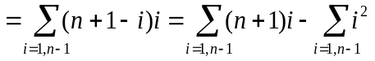

Knowing that 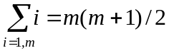, and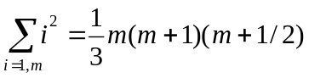, we get:

num_iter = 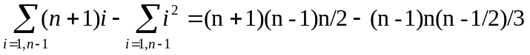

To get the total number of clock cycles for kernel execution, or “ticks” in Maxeler terminology, we multiply num_iter by g_max plus pipeline delay, and add n ticks for the initial reading of input sequence:

num_ticks = n + num_iter * (g_max + pipeline_delay)

Pipeline delay is dependent on values of kernel compile time parameters, and is obtained as a result of functional simulation of the design. According to Maxeler documentation, an estimation of kernel running time is obtained by multiplying num_ticks with a period of stream clock, which is nominally 10ns (for a frequency of 100 MHz). Estimated running times for several input grammars are presented in Table 4 along with experimental results, and discussed in the next section.

5.2. Experimental Analysis

The experiments were conducted on Maxeler MPC-C500 system with two Vectis (MAX3) dataflow engines (but only a single engine was used in all experiments), two Intel Xeon 5650 CPUs with twelve logical cores each, running at 2.67GHz, with 12Mb cache memory per processor, and with 48Gb of system memory. At the heart of Vectis dataflow engine is Virtex 5 chip (sx475t) with 100 MHz stream clock and about 4MB of on-chip RAM memory. MaxCompiler 2012.2 was used to compile kernel code. CPU code was compiled with using gcc 4.4.7 compiler with –O3 optimization level.

We used the same benchmark as in [15], that is a family of Penn Treebank grammars, constructed by processing a different percentage of Wall Street Journal (WSJ) corpus. G05 is induced by processing 5% of the corpus, G20 by processing 20% of the corpus, etc, G100 is induced from the full corpus. While G20 and lower percentage grammars could not be used in real applications due to sparsity of their terminal sets, G40 and higher percentage grammars are good representatives of grammars used in real application scenarios. These grammars are publicly freely available at http://pdos.csail.mit.edu/~amdragon/mcchart.tar.gz. Relevant properties of these grammars in binarized form are presented in Table 2.

Table 2 Properties of grammars in binarized form used in the experimental analysis
Grammar | Non-terminals | Terminals | Binary prods | Term. Prods | Unary prods | Unique pairs
G05 | 263 | 404 | 338 | 407 | 19 | 294
G20 | 679 | 1608 | 1049 | 1658 | 45 | 842
G40 | 1238 | 3144 | 2026 | 3320 | 76 | 1503
G50 | 1480 | 3891 | 2470 | 4167 | 89 | 1793
G100 | 2883 | 7300 | 4968 | 8303 | 163 | 3356

Kernel compile time parameters were explained in the previous section. It was said that parameters g_lut and g_parallel are free to choose in order to fit design onto the chip, and to achieve efficient parsing. Table 3 presents kernel on-chip memory requirements for various chosen values of g_lut (number of grammar pairs processed simultaneously by GTMEM instance) and g_parallel (number of GTMEM instances). Formulas for calculating the number of iterations, g_max and GTMEM size were given in the previous section.

Table 3 Kernel on-chip memory requirements
g_lut (bits) | g_parallel | Grammar | g_max | iterations | GTMEM size
12 | 16 | G05 | 8 | 5 | 48 MB
12 | 8 | G20 | 4 | 4 | 5.242.880 B
11 | 8 | G05 | 4 | 4 | 2.621.440 B
10 | 16 | G20 | 8 | 6 | 12 MB
10 | 16 | G50 | 16 | 12 | 48 MB
8 | 4 | G20 | 32 | 27 | 3.145.728 B
8 | 4 | G50 | 64 | 57 | 12.582.912 B
8 | 2 | G50 | 128 | 113 | 12.582.912 B
6 | 5 | G50 | 64 | 60 | 3.932.160 B
6 | 3 | G50 | 128 | 100 | 4.718.592 B
6 | 4 | G40 | 64 | 63 | 2.621.440 B
5 | 4 | G50 | 128 | 90 | 3.145.728 B
5 | 3 | G50 | 128 | 120 | 2.359.296 B
5 | 3 | G100 | 256 | 224 | 9.043.968 B
5 | 2 | G100 | 512 | 336 | 12.058.624 B

Experimental analyses were conducted for highlighted values in Table 3. Other values fail either because exceeding maximum on-chip memory capacity of Vectis dataflow unit, or failing synthesis (the typical error is congested design where router fails to route all signals, or routed design fails to meet timing constraints).

The run-time for a DFE program (shown in Table 4) does not include a call to maxload() in SLIC interface (loading bitmap into the FPGA device) because it is done only once, and then the device could be repetitively activated to parse various input sequences. We used precision UNIX time measurement library with a resolution of 1ns (because of relatively small runtimes). All measurements are averaged from repetitive running of several input sequences of the same length.

Table 4 and Fig. 16 depict speed-up factors for different lengths of input sequences and for several grammar sizes. The speed-up is better for larger grammars, and longer input sequences. As we already explained, G40 and larger grammars are representatives of real-life application grammars, and smaller grammars are included just for the sake of performance comparison The maximum grammar size and the maximum input length is limited by the chip capacity. We did not manage to put larger grammars than G50 onto the dataflow element because hardware synthesis fails, but this problem could be mitigated by using more technologically advanced dataflow elements (Vectis units we used in our experimentation are from year 2012).

Table 4 Run-times, relative errors of estimating runtimes, and speed-up factors
CFG | Pipe | Length | EstimTimeDFE | TimeDFE | Rel.Err(%) | TimeCPU | Speed-up
G50 | 17 | 10 | 3.025000e-04 | 1.012999e-03 | 70.14 | 1.885896e-02 | 18.62×
G50 | 17 | 20 | 2.189000e-03 | 2.893649e-03 | 24.35 | 1.316913e-01 | 45.51×
G50 | 17 | 30 | 7.099500e-03 | 7.733790e-03 | 8.20 | 4.448955e-01 | 57.53×
G40 | 24 | 10 | 1.828000e-04 | 8.527000e-04 | 78.56 | 1.215706e-02 | 14.26×
G40 | 24 | 20 | 1.322600e-03 | 2.081429e-03 | 36.46 | 8.995527e-02 | 43.22×
G40 | 24 | 30 | 4.289400e-03 | 5.086453e-03 | 15.67 | 2.927572e-01 | 57.56×
G40 | 24 | 40 | 9.953200e-03 | 1.081398e-02 | 7.96 | 7.848344e-01 | 72.58×
G40 | 24 | 50 | 1.918400e-02 | 1.998208e-02 | 3.99 | 1.529233e+00 | 76.53×
G20 | 24 | 10 | 1.072000e-04 | 7.933540e-04 | 86.49 | 4.020108e-03 | 5.07×
G20 | 24 | 20 | 7.754000e-04 | 1.509060e-03 | 48.62 | 2.982419e-02 | 19.76×
G20 | 24 | 30 | 2.514600e-03 | 3.216202e-03 | 21.81 | 9.566635e-02 | 29.75×
G20 | 24 | 40 | 5.834800e-03 | 6.574839e-03 | 11.26 | 2.316708e-01 | 35.24×
G20 | 24 | 50 | 1.124600e-02 | 1.369639e-02 | 17.89 | 5.521245e-01 | 40.31×
G05 | 21 | 10 | 5.890000e-05 | 8.095410e-04 | 92.72 | 4.870600e-04 | 0.60×
G05 | 21 | 20 | 4.258000e-04 | 1.096989e-03 | 61.18 | 3.572204e-03 | 3.26×
G05 | 21 | 30 | 1.380700e-03 | 1.998695e-03 | 30.92 | 1.152191e-02 | 5.76×
G05 | 21 | 40 | 3.203600e-03 | 3.652385e-03 | 12.29 | 2.953434e-02 | 8.09×
G05 | 21 | 50 | 6.174500e-03 | 6.318746e-03 | 2.28 | 5.163583e-02 | 8.17×
G05 | 21 | 60 | 1.057340e-02 | 1.046341e-02 | 1.05 | 8.578888e-02 | 8.20×

From the plot in Fig. 17 of relative errors of estimated versus real run-time for DFE parser for all data points from table 4, one can conclude that the estimation always underestimates the real run-time, and that the error is below 20% if run-times are above 5ms. The underestimation could be explained by the fact that an adopted model of estimation does not take into account overhead imposed by calling DFE element via SLIC interface from C program, and the time of actual transfer of data to and from DFE element. This overhead has some fixed component, so when the number of data processed is too small, this overhead is not negligible. It is consistent with the claim in Maxeler documentation that the system should be used for big data processing, and the warning that communicating with DFE has some overhead components.

Figure 16 Speed-up of the parallel CYK parser for different lengths of input

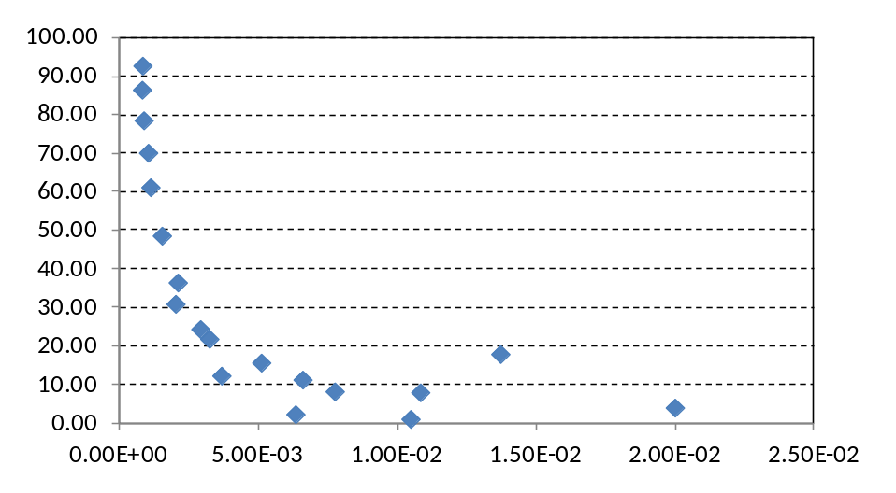
Figure 17 Distribution of relative errors of estimating run-times

6. Conclusion

Parallelizing CYK parsing has been of great interest to research community, especially with recent advanced in natural language processing and other application areas. We presented a solution to parallel CYK parsing that is realized in an innovative parallel model, namely Maxeler streaming dataflow, which is targeted to reconfigurable hardware accelerators (FPGA based). We already analyzed [8] the potential benefits and risks of Maxeler model compared to other competing parallel technologies. Considering the level of abstraction and programming productivity, the streaming dataflow model described in MaxJ language stands in half way between software parallel models like OpenMP or CUDA, and hardware description languages like VHDL.

In case of parallel CYK parsing, we managed to achieve an efficient solution of the problem with speedup factors from 18× to 76× on real-life grammars, and for different input lengths, which is the same or better than other solutions of the same problem. The solution, which is for one dataflow hardware element (or node), could be extended to multiple dataflow elements in order to be able to efficiently process even larger grammars that emerge in practical applications.

Finally, as the author of [9] points out, the hardware and software support for modern parallel architectures is rapidly growing. CPUs are produced with more and more cores, CUDA model is getting new features with each generation, and FPGA chips make constant advances in capacity and speed. Therefore, there is a clear path for constant improvements of all kinds of solutions for parallel parsing.

Acknowledgements

This work has been partially funded by the Ministry of Education and Science of the Republic of Serbia (TR32047).

7. References

- D. Jurafsky, M.H. James, Speech & language processing. Pearson Education India, 2000.
- R. Durbin, S. Eddy, A. Krogh, G. Mitchinson, ed., Biological Sequence Analysis: Probabilistic Models of Proteins and Nucleic Acids, Cambridge University Press, 1998, ISBN 978-0-521-62971-3.
- A.H. Toselli, E. Vidal, F. Casacuberta, Multimodal Interactive Pattern Recognition and Applications, Springer Science & Business Media, 2011.
- J. Moscola, J.W. Lockwood, Y.H. Cho, Reconfigurable Content-based Router Using Hardware-Accelerated Language Parser, ACM Transactions on Design Automation of Electronic Systems (TODAES) 13(2) (2008) 28.
- P. Schüller, Flexible Combinatory Categorial Grammar Parsing using the CYK Algorithm and Answer Set Programming, Logic Programming and Nonmonotonic Reasoning, Springer Berlin Heidelberg, 2013, 499-511.
- P. Shukla, S. Tokekar, S. Jain, Finding Fuzzy Reasoning Path using CYK Algorithm, Conference Anthology, IEEE , pp.1,5, 1-8 Jan. 2013.
- S. Clark, A. Copestake, J.R. Curran, Y. Zhang, A. Herbelot, Large-Scale Syntactic Processing: Parsing the Web, Final Report of the 2009 JHU CLSP Workshop, 2009.
- S. Stojanović, D. Bojić, M. Bojović, An Overview of Selected Heterogeneous and Reconfigurable Architectures, Advances in Computers, Vol. 96, 2015, pp. 1-45
- M. Johnson, Parsing in Parallel on Multiple Cores and GPUs, Australasian Language Technology Association Workshop, 2011.
- J. Cocke, Programming Languages and their Compilers: Preliminary Notes, Courant Institute of Mathematical Sciences, New York University, 1969, ISBN:B0007F4UOA.
- D.H. Younger, Recognition and Parsing of Context-Free Languages in Time O(N³), Inform. Control 10 (2) (1967) 189–208.
- T. Kasami, An Efficient Recognition and Syntax-Analysis Algorithm for Context-Free Languages (Technical Report), Hawaii Univ. Honolulu Dept. of Electrical Engineering, July 1965.
- J.L. Bordim, K. Nakano, Accelerating the CKY Parsing Using FPGAs, IEICE Transactions on Information and Systems, 86 (5) (2003) 803-810.
- J. L. Bordim, O.H. Ibarra, Y. Ito, K. Nakano, Instance-specific Solutions for Accelerating the CKY Parsing of Large Context-Free Grammars, International Journal of Foundations of Computer Science, 15 (02) (2004) 403-415.
- S. Boyd-Wickizer, A. Clements, N. Narula, Parallelizing the CKY and Earley Parsing Algorithms, (2009), Online: http://www.mit.edu/~6.863/fall2012/projects/writeups/ parallelckypaper.pdf, accessed: August 13 2015.
- C. Ciressan, E. Sanchez, M. Rajman, J.C. Chappelier, An FPGA-Based Coprocessor for the Parsing of Context-Free Grammars, In Proc. of the IEEE Symposium on Field-Programmable Custom Computing Machines, 2000.
- S. Guodong, G. Yuwan, S. Yuqiang, W. Xiaokang, Y. Aling, Word-Lattice Parsing Parallel Algorithm, 2nd International Workshop on Database Technology and Applications (DBTA), pp.1-4, 27-28 Nov. 2010
- K.H. Kim, S.M. Choi, H. Lee, K.L. Man, Y. S.Han, Parallel CYK Membership Test on GPUs. In Network and Parallel Computing, Springer Berlin Heidelberg, pp. 157-168, 2014.
- N. Takashi, T. Kentaro, K. Taura, J. Tsujii, A Parallel CKY Parsing Algorithm on Large-Scale Distributed-Memory Parallel Machines, Proceedings of the Pacific Association for Computational Linguistics, 1997, 223-231.
- A. Kos, S. Tomazic, J. Salom, N. Trifunovic, M. Valero, V. Milutinovic, New benchmarking methodology and programming model for big data processing, International journal of distributed sensor networks, ISSN 1550-1477, pp. 1-7, 2015.
- A.V. Aho, J. D. Ullman, The Theory of Parsing, Translation and Compiling, volume 1. Prentice-Hall, 1972.
- N. Chomsky, On Certain Formal Properties of Grammars, Information and Control, 2 (2) (1959) 137–167.
- J.E. Hopcroft, J.D. Ullman, Introduction to Automata Theory, Languages and Computation. Reading, Massachusetts: Addison-Wesley Publishing, 1979, ISBN 0-201-02988-X.
- S. Warshall, A Theorem on Boolean Matrices, Journal of the ACM, 9 (1) (1962) 11-12.
- Y. Yi, C.Y. Lai, S. Petrov, K. Keutzer, Efficient Parallel CKY Parsing on GPUs. In Proceedings of the 12th International Conference on Parsing Technologies , Association for Computational Linguistics, Stroudsburg, PA, USA, (2011) 175-185.
- H, Casanova, A. Legrand, Y. Robert, Parallel Algorithms, CRC Press, 2008.
- A. G. Manousopoulou, G. Manis, P. Tsanakas, and G. Papakonstantinou, Automatic Generation of Portable Parallel Natural Language Parsers. In Proceedings of the 9th conference on Tools with Artificial Intelligence, 1997.
- M. P. van Lohuizen, Parallel Processing of Natural Language Parsers, In Proceedings of the 15th Conference of Parallel Computing, 1999, 17-20.
- A. Dunlop, N. Bodenstab, B. Roark, Efficient Matrix-Encoded Grammars and Low Latency Parallelization Strategies for CYK, In Proc. of the 12th International Conference on Parsing Technologies, pp. 163–174, 2011.
- NVIDIA, NVIDIA’s Next Generation CUDA Compute Architecture: FERMI, NVIDIA, 2009.Online:http://www.nvidia.com/content/PDF/fermi_white_papers/NVIDIAFermiComputeArchitectureWhitepaper.pdf, accessed August 13, 2015.
- Maxeler Technologies, MaxCompiler White Paper, Maxeler Technologies, 2011.Online:http://www.maxeler.com/media/documents/MaxelerWhitePaperProgramming.pdf, accessed: August 13, 2015.
- V. Blagojević, et al., A Systematic Approach to Generation of New Ideas for PhD Research in Computing, Advances in Computers, Vol. 104, 2016, pp 1-19.

Appendix

A complete kernel of the parallel CYK parser, in the MaxJ dialect of the java language.

1 package cykparserv2;
2
3 import java.io.BufferedReader;
4 import java.io.FileReader;
5 import java.util.ArrayList;
6 import java.util.List;
7
8 import com.maxeler.maxcompiler.v2.kernelcompiler.Kernel;
9 import com.maxeler.maxcompiler.v2.kernelcompiler.KernelParameters;
10 import com.maxeler.maxcompiler.v2.kernelcompiler.stdlib.core.CounterChain;
11 import com.maxeler.maxcompiler.v2.kernelcompiler.stdlib.memory.Memory;
12 import com.maxeler.maxcompiler.v2.kernelcompiler.types.base.DFEType;
13 import com.maxeler.maxcompiler.v2.kernelcompiler.types.base.DFEVar;
14 import com.maxeler.maxcompiler.v2.kernelcompiler.types.composite.DFEArray;
15 import com.maxeler.maxcompiler.v2.kernelcompiler.types.composite.DFEArrayType;
16 import com.maxeler.maxcompiler.v2.utils.Bits;
17 import com.maxeler.maxcompiler.v2.utils.MathUtils;
18
19 class CykParserV2Kernel extends Kernel {
20
21 private static final DFEType type = dfeUInt(32);
22 private static final DFEType type64 = dfeUInt(64);
23
24 private BufferedReader br;
25
26 protected CykParserV2Kernel(KernelParameters parameters,
27 int ba_size, int g_max, int G_PARALLEL, int g_lut, int seq_max) {
28 super(parameters);
29
30 DFEArrayType<DFEVar> resultType =
31 new DFEArrayType<DFEVar>(type, ba_size);
32
33 DFEArrayType<DFEVar> type_glut = new DFEArrayType<DFEVar>(dfeUInt(1),g_lut);
34
35 DFEVar seq_len = io.scalarInput("seq_len", type64);
36
37 DFEVar init = control.count.pulse(seq_max);
38
39 DFEVar inp_cnt = control.count.simpleCounter(8);
40
41 DFEArray<DFEVar> input_seq = io.input("input_seq",resultType, init);
42 CounterChain chain = control.count.makeCounterChain(~init);
43 DFEVar ii = chain.addCounter(seq_len-1,1);
44 DFEVar kk = chain.addCounter(stream.offset(ii+1, -1),1);
45 DFEVar k = kk+1;
46 DFEVar j = chain.addCounter(stream.offset(seq_len-ii, -1),1);
47 DFEVar i = ii+1;
48 DFEVar gg = chain.addCounter(g_max+24,1);
49
50 int padr_bits = MathUtils.bitsToAddress(seq_max * seq_max);
51 DFEType padrt = dfeUInt(padr_bits);
52
53 List<Memory<DFEVar>> p = new ArrayList<Memory<DFEVar>>(ba_size);
54 for (int b=0; b< ba_size-1; b++) {
55 Memory<DFEVar> pm = mem.alloc(type, seq_max * seq_max);
56 p.add(pm);
57 //pm.mapToCPU("pmem"+(b+100));
58 }
59
60 int g_mems = G_PARALLEL * g_lut;
61 List<Memory<DFEVar>> g = new ArrayList<Memory<DFEVar>>(g_mems);
62 List<Memory<DFEVar>> gt =
63 new ArrayList<Memory<DFEVar>>(G_PARALLEL * (ba_size-1));
64 try {
65 br = new BufferedReader(new FileReader(
66 System.getProperty("user.dir")+"/src/cykparserv2/gmem.txt"));
67
68 for (int gi=0; gi< g_mems; gi++) {
69 Memory<DFEVar> gm = mem.alloc(type, g_max);
70 setGmContents(gm, g_max);
71 g.add(gm);
72 }
73
74 if ( ! br.readLine().equals("Check") ) {
75 System.out.println("Error: GMEM file corrupted\n");
76 System.exit(1);
77 }
78 int g_max_bits = -1;
79 while ( 1<<(++g_max_bits) < g_max )
80 ;
81 for (int gi=0; gi< G_PARALLEL; gi++) {
82 for (int b=0; b< ba_size-1; b++) {
83 Memory<DFEVar> gtmem = mem.alloc(type, (1<<g_max_bits)*(1<<g_lut));
84 setGtContents(gtmem, (1<<g_lut)*(1<<g_max_bits));
85 gt.add(gtmem);
86 }
87 }
88
89 br.close();
90 } catch (java.io.IOException e) {
91 System.out.println("Error reading memory contents:"+e.getMessage());
92 System.exit(1);
93 }
94
95 Bits[] masks = new Bits[32];
96 for (int b=0; b < 32; b++)
97 masks[b] = new Bits(32,1<<b);
98
99 Memory<DFEVar> mask = mem.alloc(type, 32);
100 mask.setContents(masks);
101
102 DFEArray<DFEVar> result = io.output("result", resultType,
103 (i === (seq_len -1)) & (k === i )
104 & (j === 0)
105 & chain.getCounterWrap(gg) );
106
107 int ba_bits = MathUtils.bitsToAddress(ba_size-1);
108 int gmax_bits = MathUtils.bitsToAddress(g_max);
109 List<DFEVar> p_rhs1 = new ArrayList<DFEVar>(ba_size);
110 List<DFEVar> p_rhs2 = new ArrayList<DFEVar>(ba_size);
111 List<DFEVar> has_lhs = new ArrayList<DFEVar>(G_PARALLEL);
112 for (int b=0; b< ba_size-1; b++) {
113 DFEVar p_rhs1_tmp = p[b].read(((k-1)* seq_max + j).cast(padrt));
114 p_rhs1.add( p_rhs1_tmp );
115 DFEVar p_rhs2_tmp = p[b].read(((i - k)* seq_max + j + k).cast(padrt));
116 p_rhs2.add( p_rhs2_tmp );
117 }
118 for (int gi=0; gi < G_PARALLEL; gi++) {
119 DFEArray<DFEVar> has_lhs_gi = type_glut.newInstance(this);
120 for (int gj=0; gj < g_lut; gj++) {
121 DFEVar g_last = g[gi * g_lut + gj].read(gg.slice(0,gmax_bits));
122 DFEVar rhs1w = control.mux(g_last.slice(5,ba_bits), p_rhs1);
123 DFEVar rhs2w = control.mux(g_last.slice(21,ba_bits), p_rhs2);
124 DFEVar has_rhs1 = ( rhs1w & mask.read(g_last.slice(0,5)) );
125 DFEVar has_rhs2 = ( rhs2w & mask.read(g_last.slice(16,5)) );
126 has_lhs_gi[gj] <==
127 optimization.pipeline((has_rhs1 !== 0 ) & (has_rhs2 !== 0 )) ;
128 }
129 DFEVar has_lhs_tmp = has_lhs_gi.pack();
130 has_lhs.add( has_lhs_tmp );
131 }
132
133 for (int b=0; b< ba_size-1; b++) {
134
135 DFEVar oldp = ((k===1)|(kk===0))
136 ? constant.var(type,0)
137 : p[b].read((i * seq_max + j).cast(padrt));
138
139 for (int gi=0; gi < G_PARALLEL; gi++) {
140
141 DFEVar gt_gi = gt[gi*(ba_size-1)+b].read(
142 gg.slice(0,gmax_bits).cat(has_lhs[gi]));
143
144 DFEVar gt_tmp0 = type.newInstance(this);
145 DFEVar gt_tmp1 = type.newInstance(this);
146 gt_tmp0 <== (gg.slice(0) === 0)
147 ? constant.var(type,0)
148 : (stream.offset(gt_tmp0,-2) | gt_gi);
149
150 gt_tmp1 <== (gg.slice(0) === 1)
151 ? constant.var(type,0)
152 : (stream.offset(gt_tmp1,-2) | gt_gi);
153
154 DFEVar gt_tmp = stream.offset(gt_tmp0,-1) | gt_tmp1;
155 // if even g_max exchange gt_tmp1 and gt_tmp0
156
157 oldp |= stream.offset(gt_tmp,-14);
158 }
159 DFEVar ooldp = stream.offset(oldp,-10);
160 p[b].write( (init) ? (inp_cnt).cast(padrt) : (i * seq_max + j).cast(padrt),
161 (init)? input_seq[b] : ooldp ,init | chain.getCounterWrap(gg));
162 }
163
164 result[ba_size-1] <== input_seq[ba_size-1];
165
166 }
167
168 protected void setGmContents(Memory<DFEVar> gm, int gm_size)
169 throws java.io.IOException {
170 String g_str = null;
171 g_str = br.readLine();
172 //g_str = new String(new char[gm_size*8]).replace("\0", "0");
173 Bits[] gm_bits = new Bits[gm_size];
174 for (int gi=0; gi < gm_size; gi++) {
175 gm_bits[gi] = new Bits(32,g_str.substring(gi*8,gi*8+8));
176 }
177 gm.setContents(gm_bits);
178 }
179
180 protected void setGtContents(Memory<DFEVar> gtmem, int gt_size)
181 throws java.io.IOException {
182 String g_str = null;
183 g_str = br.readLine();
184 //g_str = new String(new char[gt_size*8]).replace("\0", "0");
185 Bits[] gt_bits = new Bits[gt_size];
186 for (int gi=0; gi < gt_size; gi++) {
187 gt_bits[gi] = new Bits(32,g_str.substring(gi*8,gi*8+8));
188 }
189 gtmem.setContents(gt_bits);
190 }
191 }

About the Authors

Dragan Bojić received a Ph.D. degree in Electrical Engineering and Computer Science from the University of Belgrade in 2001. He is an associate professor at the School of Electrical Engineering, University of Belgrade. His research interests include formal languages and parsing, software engineering techniques and tools, and e-learning.

Miroslav Bojović received a Ph.D. in Computer Engineering from the University of Belgrade, in 1988. He is an associate professor at the Faculty of Electrical Engineering, University of Belgrade, where he teaches database managements systems. Previously, he was with the Pupin Institute, Belgrade and UCLA, Los Angeles. His research interests include database management systems, distributed information systems, fault tolerant computing, software engineering, and internet technologies.

